**Q#1**

org 100h

var1 dw 11h

var2 dw 7h

mov dx,var1

mov cx,var2

MUL dx

ret

**OUTPUT:**

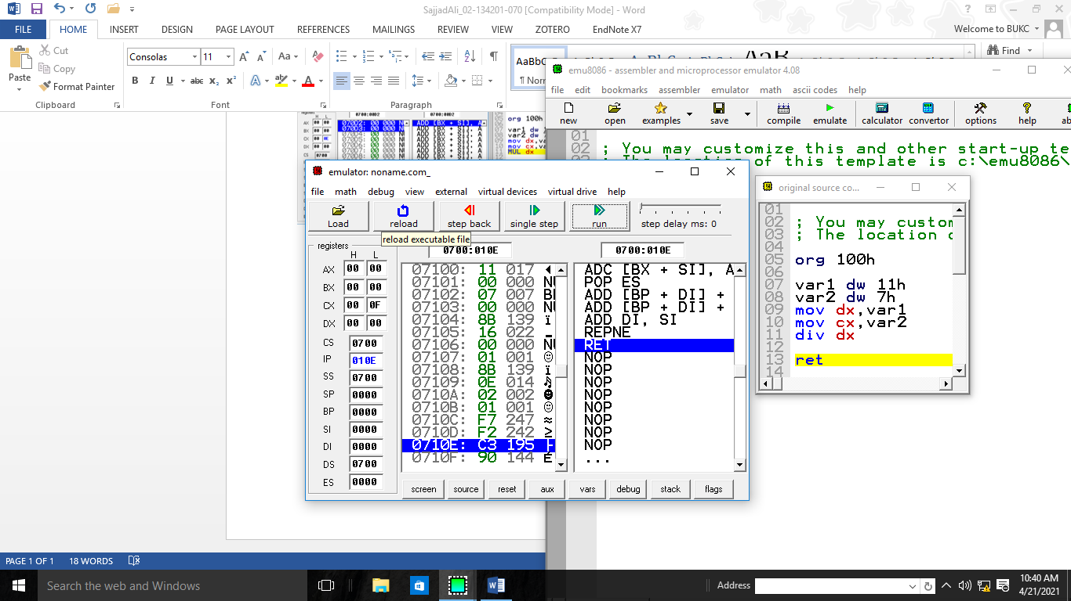

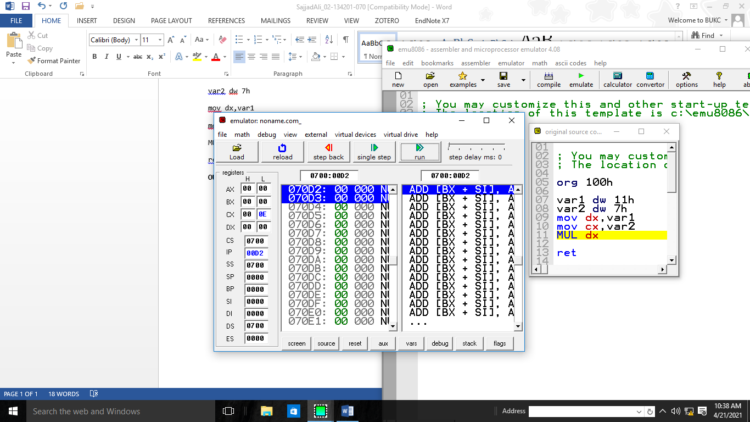

2)

org 100h

mov al,00000111b

XOR al,00000010b;

ret

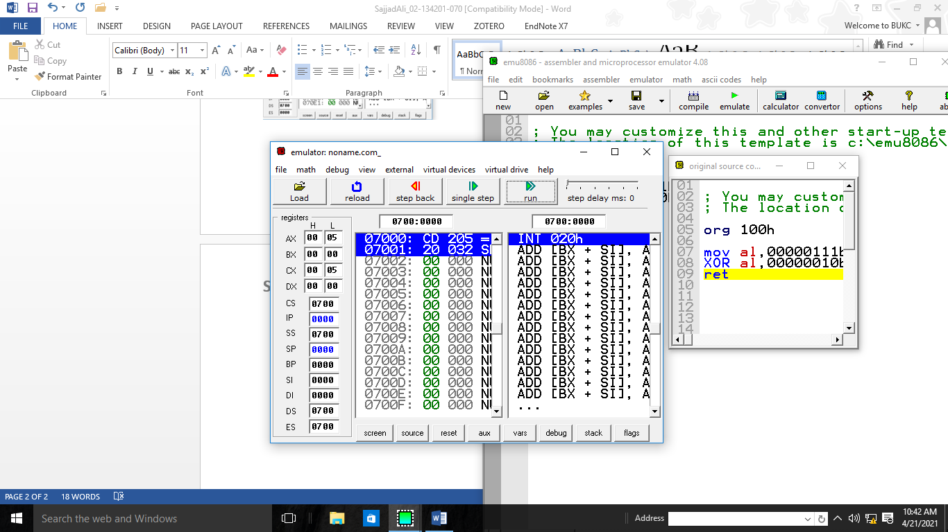

Q#2

AX for 16 bits 🡪 00001111

EAX for 32 bits 🡪 0000000000001111

org 100h

mov al,'A';AL=01000001b

OR AL,00100000b; AL=01100001b('a')

ret

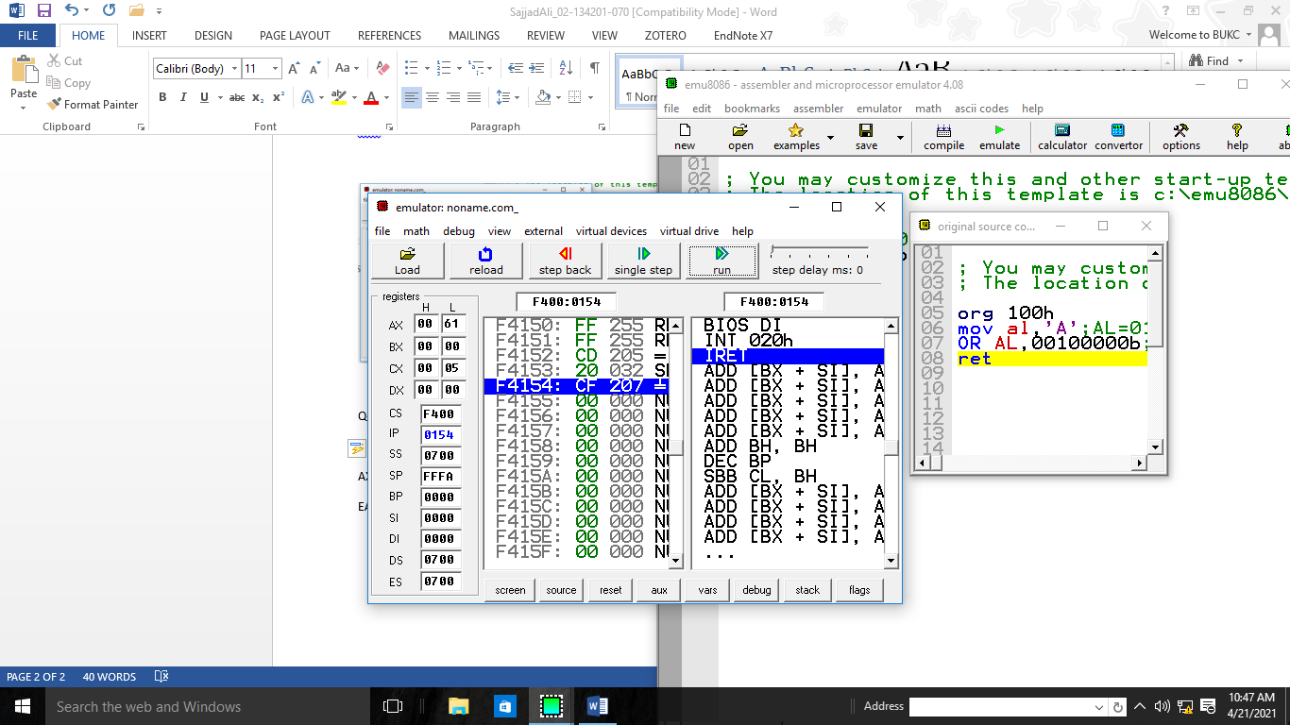

**Q#3:**

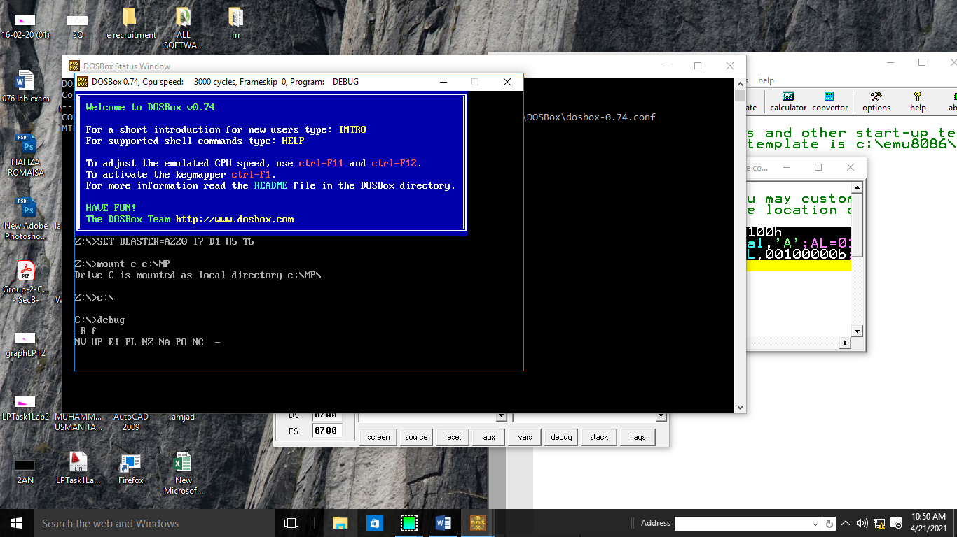

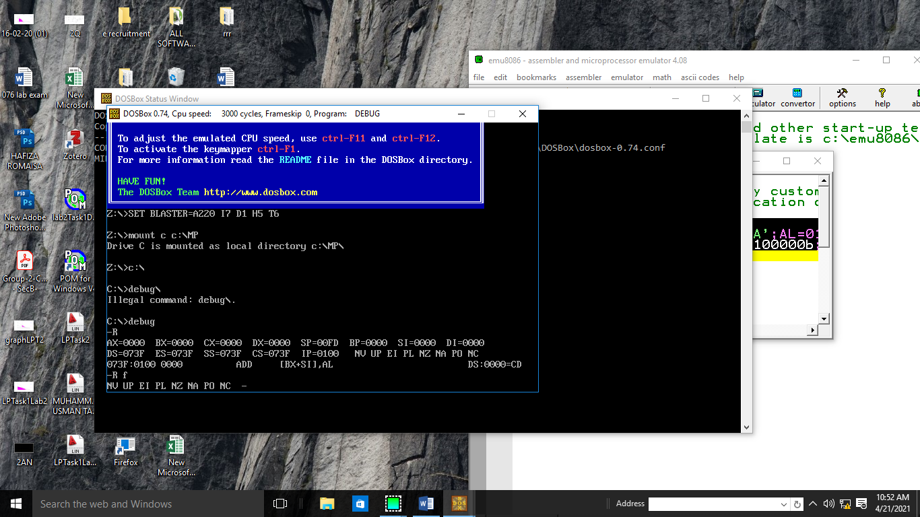

**Q#4:**

As we know ‘dw’ is use for 16 bit and bx is used for 8 bits;

In Var2 we have a value of 16 bit;

We try to move a 16 bit value into 8 bit register

That’s is error in this program